**Manitoba Supplement**

**Worker Safety Representative Policy:**

In accordance with the Manitoba Workplace Safety and Health Act Section 41, a worker not associated with management shall be designated the worker safety and health representative for a work site according to the following requirements ():

1. at a workplace, other than a construction project, where a safety and health committee is not required but where 10 or more workers are regularly employed;
2. at a construction project, notwithstanding the requirements for a safety and health committee; and
3. at any other individual workplace or classes of workplaces which the minister may designate.

The Duties and Responsibilities of Safety and Health Representatives:

* Inspect dangerous conditions and/or call a special meeting to resolve any concerns. Protect the anonymity of complainants who request it.
* Notify complainants of any decisions or recommendations made to management relating to their concerns.
* Notify all workers at any site where the work is determined to be dangerous.
* At regular intervals, the safety rep along with site supervisor / foreman (management), should inspect each part of the worksite and the operations therein, and should resolve any safety or health concerns identified during the inspection.
* The safety rep and site supervisor / foreman shall jointly investigate accidents and dangerous occurrences at the workplace.
* Carry out hazard identification at the beginning of all new work projects, tasks, equipment, project changes, etc. This shall include: the types of tasks performed, operating methods used and problems which may be encountered. Review the safety of new equipment, materials, or processes and make recommendations accordingly.
* Hold meetings / discussions with staff to discuss, evaluate and get input on safety and health matters.
* Distribute and display safety and health information and educational materials relevant to your worksite.

**Policy Implemented: June 1, 2016**

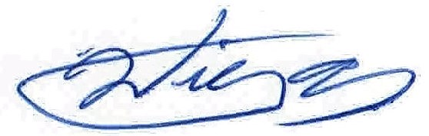



**Signed: _______________________________ Review Date: June 1, 2016**

**Willy Toews – Company Owner**

**Hearing Conservation Program**

Bristal Hauling Inc. will put into effect a hearing conservation program for work areas where exposure to noise is in excess of 80 dBA.

All employees shall wear hearing protection if the noise or sound level at any workplace exceeds 80 decibels (A-weighted or dBA) while noisy work is being performed. Hearing protection reduces the noise exposure level and the risk of hearing loss.

Select hearing protection that is:

* Correct for the job. Refer to the Canadian Standards Association (CSA) Standard Z94.2-02 (Reaffirmed 2007);
* Provides adequate protection. Check the manufacturer's literature;
* Comfortable enough to be accepted and worn.

**What are the advantages and limitations of ear plugs and ear muffs?**

|  |  |
| --- | --- |
| **Comparison of Hearing Protection** | |
| **Ear Plugs** | **Ear Muffs** |
| **Advantages:**   * small and easily carried * convenient to use with other personal protection equipment (can be worn with ear muffs) * more comfortable for long-term wear in hot, humid work areas * convenient for use in confined work areas | **Advantages:**   * less attenuation variability among users * designed so that one size fits most head sizes * easily seen at a distance to assist in the monitoring of their use * not easily misplaced or lost * may be worn with minor ear infections |
| **Disadvantages:**   * requires more time to fit * more difficult to insert and remove * require good hygiene practices * may irritate the ear canal * easily misplaced * more difficult to see and monitor usage | **Disadvantages:**   * less portable and heavier * more inconvenient for use with other personal protective equipment. * more uncomfortable in hot, humid work area * more inconvenient for use in confined work areas * may interfere with the wearing of safety or prescription glasses: wearing glasses results in breaking the seal between the ear muff and the skin and results in decreased hearing protection. |

In order to get full benefit, hearing protectors must be worn all the time during noisy work. If hearing protectors are removed only for a short duration, the protection is substantially reduced. The following table gives a maximum protection provided for non-continuous use of an ideally fitted "100%" efficient hearing protector. For example if one takes off his/her hearing protector for 5 min in an 8-hour shift, the maximum protection will be 20 dB. The following table gives other examples.

|  |  |
| --- | --- |
| **Maximum protection provided by non-continuous use of Hearing Protection** | |
| **Percent time used** | **Maximum Protection** |
| 50% | 3 dB |
| 60% | 4 dB |
| 70% | 5 dB |
| 80% | 7 dB |
| 90% | 10 dB |
| 95% | 13 dB |
| 99% | 20 dB |
| 99.9% | 30 dB |

 Ear protectors must be used **ALL THE TIME** to get full benefit.

**How should I care for my hearing protection device?**

* Follow the manufacturer's instructions.
* Check hearing protection regularly for wear and tear.
* Replace ear cushions or plugs that are no longer pliable.
* Replace a unit when head bands are so stretched that they do not keep ear cushions snugly against the head.
* Disassemble ear muffs to clean.
* Wash ear muffs with a mild liquid detergent in warm water, and then rinse in clear warm water. Ensure that sound-attenuating material inside the ear cushions does not get wet.
* Use a soft brush to remove skin oil and dirt that can harden ear cushions.
* Squeeze excess moisture from the plugs or cushions and then place them on a clean surface to air dry. (Check the manufacturer's recommendations first to find out if the ear plugs are washable.)

**Policy Implemented: June 1, 2016**

**Signed: _______________________________ Review Date: June 1, 2016**

**Willy Toews – Company Owner**

**– Noisy Worksite Sound Tests Record Sheet –**

|  |  |  |  |  |  |  |
| --- | --- | --- | --- | --- | --- | --- |
| **Worksite Location** | **Date** | **Test 1 Highest dBA** | **Test 2 Highest dBA** | **Test 3 Highest dBA** | **Test 4 Highest dBA** | **Sound Protection Required** |
|  |  |  |  |  |  |  |
|  |  |  |  |  |  |  |
|  |  |  |  |  |  |  |
|  |  |  |  |  |  |  |
|  |  |  |  |  |  |  |
|  |  |  |  |  |  |  |
|  |  |  |  |  |  |  |
|  |  |  |  |  |  |  |
|  |  |  |  |  |  |  |
|  |  |  |  |  |  |  |
|  |  |  |  |  |  |  |

**WHMIS Policy**

Bristal Hauling Inc. shall provide training to every worker who works with or in proximity to any hazardous or controlled substance.

In accordance with WHMIS requirements, all products shall be properly labeled and stored as required by the manufactures specifications.

All new employees shall be trained in WHMIS and shall be tested and certification test prior to handling controlled products. Employees already trained in WHMIS shall receive refresher training at least once per year and a certification test. The certification test shall be administered to all employees working with controlled substances by their supervisor and retained on file.

Certification Tests will be developed by the supervisor.

MSDS for all controlled substance in use on a work site shall be maintained and updated in accordance with required legislation. The MSDS will be readily available in the work site binder.

**Policy Implemented: June 1, 2016**

**Signed: _______________________________ Review Date: June 1, 2016**

**Willy Toews – Company Owner**

**– WHMIS Controlled Product Inventory –**

|  |  |  |  |
| --- | --- | --- | --- |
| **Worksite Location** | **Controlled Product Identifier** | **Manufacturer Name** | **MSDS Date** |
|  |  |  |  |
|  |  |  |  |
|  |  |  |  |
|  |  |  |  |
|  |  |  |  |
|  |  |  |  |
|  |  |  |  |
|  |  |  |  |
|  |  |  |  |
|  |  |  |  |
|  |  |  |  |

**WHMIS Test** (20 Minutes)

1. What does **WHMIS** stand for?
2. Identify each of the following symbols commonly found on supplier labels: (1/4 point each)



For each of the following questions **circle the most appropriate answer.**

1. A complete list of all hazardous materials controlled under WHMIS is available from the Government of Canada.

a. True b. False

1. WHMIS applies to the following classes of hazardous materials:
   1. Consumer Products
   2. Drugs
   3. Flammable and combustible material
2. The three elements of WHMIS are:
   1. Supplier Information, Product Labels and Emergency Information
   2. MSDS, Transportation Documentation and Emergency Information
   3. Product Labels, MSDS and Worker Education.
3. A hazardous material classified under Class D, Division 1, Material Causing Immediate and Serious Toxic Effects:
   1. Refers to an organism or its toxins that may cause serious infectious disease
   2. Will cause harmful effects including death within a short period of time after exposure
   3. Will cause harmful effects after days, month or years after one or more exposures.
   4. All of the above
4. Two types of WHMIS labels are:
   1. Pesticide and Explosive Labels
   2. Supplier and Transportation Labels
   3. Workplace and Consumer Labels
   4. Supplier and Workplace Labels
5. WHMIS labels must be applied on:
   1. Tobacco or products made of tobacco
   2. Consumer products
   3. Transported products
   4. Controlled products
   5. None of the above
6. The three pieces of information required on a Workplace label are:
   1. Supplier identifier, Product Identifier, and Reference to the MSDS
   2. Product Identifier, Emergency telephone number, and Hazard Symbol
   3. Product Identifier, Safe Handling Information, and Reference to the MSDS
   4. None of the above
7. A controlled product may fall under more than one hazard classes and therefore the supplier label for that product will have more than one hazard symbol on it.

a. True b. False

**Page 1 of 2**

1. A container into which you transferred a hazardous product from the original supplier container;
   1. Requires a Transportation of Dangerous Goods (TDG) label
   2. Requires no label because the original container has a supplier label.
   3. Requires a workplace label
   4. Requires a supplier label
   5. None of the above
2. The acronym MSDS stands for:
   1. Manufacturers Safety Data Sheets
   2. Materials Safety Diagnostic Sheets
   3. Mines Safety Direction Sheets
   4. Material Safety Data Sheets
   5. None of the above.
3. An MSDS is available in the work place:
   1. to assist the purchasing department in buying chemicals
   2. To describe to you the nature of the processes in the work place.
   3. to provide detailed hazard and safety information about the material
   4. none of the above
4. For a controlled product, the greater the evaporation rate, the more quickly it will create a vapour hazard.

a. True b. False

1. An MSDS should be consulted:
   1. Only by safety professionals
   2. Only in emergency situations
   3. Before you use a controlled product
   4. Occasionally to review hazard and precautionary information
   5. a and d
   6. c and d
2. The **LC50** and the **LD50** of a material gives an indication of how toxic the material is.

a. True b. False

1. The larger the **LD50**, the more toxic the substance

a. True b. False

1. Oxidizers and Flammable materials are incompatible and should not be stored together

a. True b. False

1. For flammable materials, lower the flash point, the greater is the fire hazard.

a. True b. False

1. If the vapour of a flammable substance with a flash point of 4 degrees C kept in a room at 23 degrees C comes into contact with a flame,
   1. the vapour will ignite and cause an explosion
   2. the vapour will not ignite because the flash point is lower than 20 degrees C
   3. The vapour will ignite if its concentration in air is within the specific upper and lower flammability limits.

**Test Score: / 20 (Required 16/20 to pass)**

**Signed: Date:**

**Employee**

**Signed: Date:**

**Examiner**

**Page 2 of 2**

**WHMIS Test Answer Key**

1. What does **WHMIS** stand for? **Workplace Hazardous Material Information System**
2. Identify each of the following symbols commonly found on supplier labels:



Combustible or Flammable material

Corrosive Material

Reactive Material

Compressed Gas

For each of the following questions **circle the most appropriate answer.**

1. A complete list of all hazardous materials controlled under WHMIS is available from the Government of Canada.

a. True b. False

1. WHMIS applies to the following classes of hazardous materials:
   1. Consumer Products
   2. Drugs
   3. Flammable and combustible material
2. The three elements of WHMIS are:
   1. Supplier Information, Product Labels and Emergency Information
   2. MSDS, Transportation Documentation and Emergency Information
   3. Product Labels, MSDS and Worker Education.
3. A hazardous material classified under Class D, Division 1, Material Causing Immediate and Serious Toxic Effects:
   1. Refers to an organism or its toxins that may cause serious infectious disease
   2. Will cause harmful effects including death within a short period of time after exposure
   3. Will cause harmful effects after days, month or years after one or more exposures.
   4. All of the above
4. Two types of WHMIS labels are:
   1. Pesticide and Explosive Labels
   2. Supplier and Transportation Labels
   3. Workplace and Consumer Labels
   4. Supplier and Workplace Labels
5. WHMIS labels must be applied on:
   1. Tobacco or products made of tobacco
   2. Consumer products
   3. Transported products
   4. Controlled products
   5. None of the above
6. The three pieces of information required on a Workplace label are:
   1. Supplier identifier, Product Identifier, and Reference to the MSDS
   2. Product Identifier, Emergency telephone number, and Hazard Symbol
   3. Product Identifier, Safe Handling Information, and Reference to the MSDS
   4. None of the above
7. A controlled product may fall under more than one hazard classes and therefore the supplier label for that product will have more than one hazard symbol on it.

a. True b. False

1. A container into which you transferred a hazardous product from the original supplier container;
   1. Requires a Transportation of Dangerous Goods (TDG) label
   2. Requires no label because the original container has a supplier label.
   3. Requires a workplace label
   4. Requires a supplier label
   5. None of the above
2. The acronym MSDS stands for:
   1. Manufacturers Safety Data Sheets
   2. Materials Safety Diagnostic Sheets
   3. Mines Safety Direction Sheets
   4. Material Safety Data Sheets
   5. None of the above.
3. An MSDS is available in the work place:
   1. to assist the purchasing department in buying chemicals
   2. To describe to you the nature of the processes in the work place.
   3. to provide detailed hazard and safety information about the material
   4. none of the above
4. For a controlled product, the greater the evaporation rate, the more quickly it will create a vapour hazard.

a. True b. False

1. An MSDS should be consulted:
   1. Only by safety professionals
   2. Only in emergency situations
   3. Before you use a controlled product
   4. Occasionally to review hazard and precautionary information
   5. a and d
   6. c and d
2. The **LC50** and the **LD50** of a material gives an indication of how toxic the material is.

a. True b. False

1. The larger the **LD50**, the more toxic the substance

a. True b. False

1. Oxidizers and Flammable materials are incompatible and should not be stored together

a. True b. False

1. For flammable materials, lower the flash point, the greater is the fire hazard.

a. True b. False

1. If the vapour of a flammable substance with a flash point of 4 degrees C kept in a room at 23 degrees C comes into contact with a flame,
   1. the vapour will ignite and cause an explosion
   2. the vapour will not ignite because the flash point is lower than 20 degrees C
   3. The vapour will ignite if its concentration in air is within the specific upper and lower flammability limits.

**TDG Test** (20 Minutes)

1. What does **TDG** stand for?
2. Identify each of the following placards commonly found as one of the 9 classes: (1/4 point each)

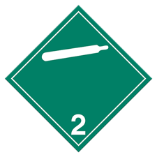_____________________________ 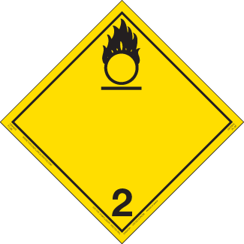_________________________________

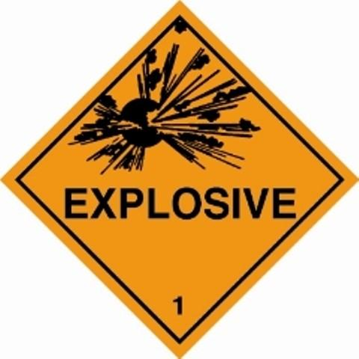_____________________________ 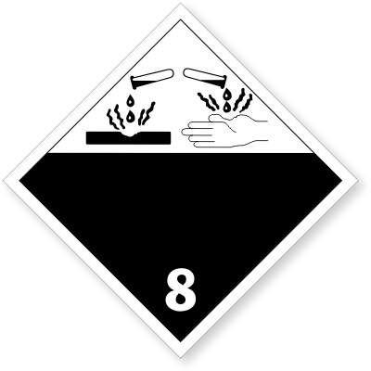_________________________________

For each of the following questions **circle the most appropriate answer.**

1. What does the **16** in Column 5 mean for Corrosive Liquid, n.o.s.?
   1. Maximum 16 litres permitted on a passenger carrying vehicle
   2. More than 16 litres requires an emergency response assistance plan
   3. A technical name must be added to the shipping name
2. The colour of the label on a cylinder of helium is:
   1. Red
   2. Green
   3. Blue
3. Toxic gases are:
   1. Easily ignited
   2. Hazardous only because they are compressed
   3. Poisonous or corrosive
4. The background colour of the **DANGEROUS WHEN WET** label is:
   1. Blue
   2. Green
   3. Red
5. Hydrochloric acid is UN 1789.

a. True b. False

1. Acetone is in Packing Group III.

a. True b. False

1. The subsidiary class for Mercury is 3.

a. True b. False

1. Class 2, GASES have no packing groups.

a. True b. False

**Page 1 of 2**

1. The 24-hour contact number which must appear on every dangerous goods shipping document should belong to:
   1. The consignee
   2. The shipper
   3. The local police
   4. The trucking company
2. If a product has more than one type of hazard, how must the subsidiary risk be indicated on the shipping document?
   1. Listed before the primary risk
   2. Listed below the primary risk
   3. Shown in brackets after the primary risk
3. The quantity of dangerous goods must be in metric on the shipping document.

a. True b. False

1. What does ERAP stand for?
   1. Emergency Response Action Plan
   2. Emergency Response Assistance Plan
   3. Emergency Response Assistance Policy
2. How long must shippers and carriers keep a copy of the dangerous goods shipping document on file?
   1. 6 months
   2. 3 years
   3. 2 years
3. If a small container is emptied of all traces of dangerous goods, the labels must be covered or removed.

a. True b. False

1. In addition to a class label and UN number, what information must appear on the outside of a package containing acetone?
   1. The quantity of dangerous goods
   2. 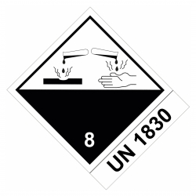The shipping name **ACETONE**
   3. 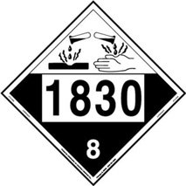The flash point
2. The UN number can be printed beside the dangerous good or on it.

a. True b. False

1. Ethylene dichloride is Class 3 (6.1). The container must show labels for both the primary and subsidiary risks.

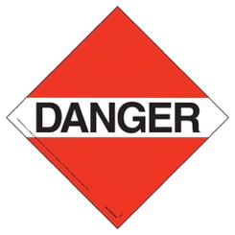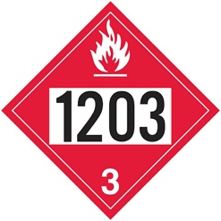a. True b. False

**1203**

1. A tank truck carrying gasoline, UN 1203, Class 3, requires: a) b) c)
   1. Flammable liquid placards and 1203
   2. DANGER placards
   3. No placards, just 1203

**Test Score: / 20 (Required 16/20 to pass)**

**Signed: Date:**

**Employee**

**Signed: Date:**

**Examiner**

**Page 2 of 2**

**TDG Test ANWER SHEET**

1. What does **TDG** stand for? **Transportation of Dangerous Goods**
2. Identify each of the following placards commonly found as one of the 9 classes: (1/4 point each)

**2.2 Non-Flammable, Non-Toxic Gas 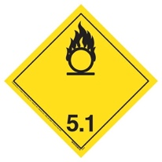5.1 Oxidizer**

**1 Explosives**  **8 Corrsives**

For each of the following questions **circle the most appropriate answer.**

1. What does the **16** in Column 5 mean for Corrosive Liquid, n.o.s.?
   1. Maximum 16 litres permitted on a passenger carrying vehicle
   2. More than 16 litres requires an emergency response assistance plan
   3. A technical name must be added to the shipping name
2. The colour of the label on a cylinder of helium is:
   1. Red
   2. Green
   3. Blue
3. Toxic gases are:
   1. Easily ignited
   2. Hazardous only because they are compressed
   3. Poisonous or corrosive
4. The background colour of the **DANGEROUS WHEN WET** label is:
   1. Blue
   2. Green
   3. Red
5. Hydrochloric acid is UN 1789.

a. True b. False

1. Acetone is in Packing Group III.

a. True b. False

1. The subsidiary class for Mercury is 3.

a. True b. False

1. Class 2, GASES have no packing groups.

a. True b. False

1. The 24-hour contact number which must appear on every dangerous goods shipping document should belong to:
   1. The consignee
   2. The shipper
   3. The local police
   4. The trucking company
2. If a product has more than one type of hazard, how must the subsidiary risk be indicated on the shipping document?
   1. Listed before the primary risk
   2. Listed below the primary risk
   3. Shown in brackets after the primary risk
3. The quantity of dangerous goods must be in metric on the shipping document.

a. True b. False

1. What does ERAP stand for?
   1. Emergency Response Action Plan
   2. Emergency Response Assistance Plan
   3. Emergency Response Assistance Policy
2. How long must shippers and carriers keep a copy of the dangerous goods shipping document on file?
   1. 6 months
   2. 3 years
   3. 2 years
3. If a small container is emptied of all traces of dangerous goods, the labels must be covered or removed.

a. True b. False

1. In addition to a class label and UN number, what information must appear on the outside of a package containing acetone?
   1. The quantity of dangerous goods
   2. 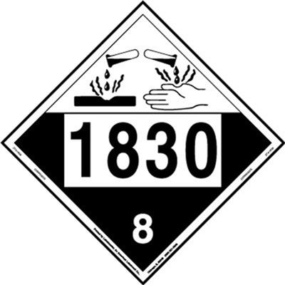The shipping name **ACETONE**
   3. The flash point
2. The UN number can be printed beside the dangerous good or on it.

a. True b. False

1. Ethylene dichloride is Class 3 (6.1). The container must show labels for both the primary and subsidiary risks.

a. True b. False

**1203**

1. A tank truck carrying gasoline, UN 1203, Class 3, requires: a) b) c)
   1. Flammable liquid placards and 1203
   2. DANGER placards
   3. No placards, just 1203

**Harassment and Violence in the Workplace Policy**

All employees of Bristal Hauling Inc. are entitled to a work in an environment free of harassment and violence. Bristal Hauling Inc. will take all reasonable measures to ensure that no employee is exposed to harassment and violence during their employment by enforcing a “zero tolerance” policy. Violators of the policy will be subject to disciplinary action in accordance with company discipline procedures, or at the discretion of Senior Management.

Workplace Safety & Health Legislation defines “Harassment” as: any objectionable conduct, comment or display by a person that is directed at a worker in a workplace or is made on the basis of race, creed, religion, colour, sex, sexual orientation, gender determined characteristics, political belief, political association, political activity, marital status, family status, source of income, disability, size or weight, age, nationality, ancestry or place of origin and which creates a risk to the health of a worker.

Workplace Safety & Health Legislation defines “Violence” as: the attempted or actual exercise of physical force against a person; and any threatening statement or behavior that gives a person reasonable cause to believe that physical force will be used against the person.

All employees must report harassment or violence complaints to their immediate supervisor upon occurrence. The Supervisor in conjunction with Senior Management and the Safety Committee/Worker Representative will investigate each compliant while maintaining confidentiality. The details of the complaint investigation will be documented, interviews may be conducted and the complainant and the alleged harasser will be informed of the results of the investigation. Details of the investigation may only be disclosed if particulars are necessary to proceed with the investigation of the complaint, take corrective action, or are required by law. Employees have the right to file a complaint with the Manitoba Human Rights Commission. Workers will be made aware of this policy through their orientations and a copy will be posted prominently in the workplace.

When an employee observes an act or behavior that is perceived to be threatening in nature which poses a potential risk to their own or others safety and health, the following procedures must be followed:

Employees:

* Move to a safe location and report the incident to your Supervisor immediately;
* Provide complete details of the incident;
* Do not try to resolve the incident yourself or interfere with violent individuals.

Supervisors/Senior Management:

* Investigate all reported complaints of violence within 24 hours by completing a company investigation report form;
* Attempt to diffuse the situation by discussion with affected parties;
* Interview, if necessary, alleged violators of the company policy;
* If a safe resolution is not possible, contact outside assistance such as: Workplace Safety & Health or the local Police Department;
* Inform the alleged violator and complainant of the results of the investigation.

**Policy Implemented: June 1, 2016**

**Signed: _______________________________ Review Date: June 1, 2016**

**Willy Toews – Company Owner**

**HARASSMENT COMPLAINT FORM**

1. Name of complainant:
2. Person(s) suspected of harassment (respondent):
3. Nature of the allegations:
4. Date(s), time(s) and place(s) where the incident(s) took place:
5. Did anyone witness the incident? yes no

(If yes) Name(s) of witness (es):

Description of their respective role in the incident:

How did you react to the harassment?

1. If applicable, describe any incident that took place previously:

I am filing this complaint because I honestly believe that the reported person or persons have been harassing me.

I hereby certify that to the best of my knowledge the above-mentioned information is true, accurate and complete. Making false or frivolous allegations is in violation of this policy and subject to disciplinary action.

Furthermore, I realize that an inquiry will be initiated once this complaint has been filed.

_________________________________________ _____________________________________

Signature of the complainant Date

_________________________________________ _____________________________________

Signature Company Management Date