Legislation is law.

Bristal Hauling Inc. will follow all requirements as set forth by Manitoba Workplace Safety and Health Division in the Workplace Safety and Health Act and the Regulations.

The Workplace Safety and Health Act spells out the legal duties and responsibilities of people found in the workplace. Specific duties and responsibilities are listed for:

- Employers;
- Supervisors;
- Workers;
- Self-Employed Persons;
- Prime Contractor;
- Contractors;
- Owners;
- Suppliers;
- Safety Committee Members / Worker Safety Reps.

Copies of relevant legislation (WSH Act and applicable Regulations) will be posted and made readily available for workers and supervisors at each jobsite or workplace.

Supervisors are required review and reference to legislation or regulations during their job planning.

Workers will have access to the legislation as part of their right to participate in their own safety and health. Each worker will be informed of their fundamental rights as a worker in Manitoba during the worksite orientation.

Worker Rights
Every worker has the right to:
- know about hazards in the workplace, and which precautions must be taken to prevent injury or illness from these hazards.
- Employee education under the Workplace Hazardous Materials Information System, as well as job-specific training on chemical/controlled products at the workplace, is an example of the right to know, supported by The Workplace Safety and Health Act.
- participate in safety and health activities at the workplace, including involvement in the joint workplace safety and health committee, or as a worker representative, for example.
- refuse work for anything that the worker believes will cause immediate and serious, or long term effects on their safety and health or the safety and health of others.
- carry out duties or exercise safety and health rights, as set out under The Workplace Safety and Health act without being subject to discriminatory action.

Worker Responsibilities
Workers have the legal responsibility to:
- take reasonable care to protect themselves and others who may be affected by their actions or omissions.
- make proper use of safety equipment, clothing, and devices.
- cooperate with the workplace safety and health committee or representative.
- cooperate with other persons regarding workplace safety and health matters.

Policy Implemented: June 1, 2016

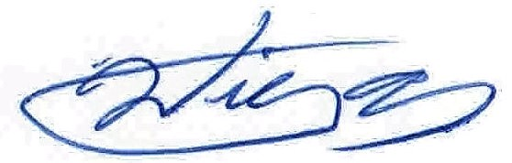

Signed: _______________________________ Review Date: June 1, 2016
Willy Toews – Company Owner

